**SOFTWARE REQUIREMENTS SPECIFICATION (SRS)**

**DOCUMENT**



**Dilara Bayar - 150115022**

**Firdevs Mersin - 150115063**

**Serdar Sayın - 150115068**

**PURPOSE**

Designing an application that provides to cyclist for creating their own critical mass event (The number of cyclists has to come to a threshold value for cars to give way to cyclists while the intersection on main streets is turning, this number is called critical mass).

**SCOPE**

“City Cyclers” is open to all users, and also people who prefers cycling as a sport or as a hobby. It is an application that enables people have rights on traffic in the city life.

On this application we create a timeline that includes cyclists’ events.

The users can vote other people’s events so thanks to our application, social network occurs.

The users have their profile has personal information and photographs.

Our app will contain home, login, signup, profile, event details and map pages.

Map page shows us route of going. Event details includes details of event such as time, location and explanation of creator and also comment line for users. The users can vote the event whether joining of event.

**DEFINITIONS, ACRONYMS, AND ABBREVIATIONS**

|  |  |
| --- | --- |
| **Term/Abbreviations** | **Explanation** |
|  |  |
|  |  |
|  |  |
|  |  |

|  |  |
| --- | --- |
| **Term** | **Definitions** |
| User | A potential user of the application. |
| Critical Mass | The number of cyclists has to come to a threshold value for cars to give way to cyclists while the intersection on main streets is turning. |
| Scope Creep | It refers to a project that has seen its original goals expand while it's in progress. |
| Project Cost | The price paid to acquire for software project |
| Risk | What can go wrong and what can done about it on project. |

**REFERENCES**

<https://krazytech.com/projects/sample-software-requirements-specificationsrs-report-airline-database>

<http://se.inf.ethz.ch/courses/2011a_spring/soft_arch/exercises/02/Requirements_Specification.pdf>

**GENERAL CONSTRAINTS**

* If necessary, **resources** are not available, **time** to deliver will increase. This may also increase project **cost**, because alternate resources, if available, may be more expensive than planned.
* If [**scope creep**](https://resources.workfront.com/project-management-blog/best-practices-for-scope-management?proxy=/blog/) happens on the project, it will result in increased **time, cost, resources,** and potentially reduced **quality**. And thus, increased **risk** on delivery.
* Fixed sixes team
* Some course laws that restrict project options

**ASSUMPTIONS AND DEPENDENCIES**

It’s assumed that user have an internet access and have knowledge about phone use.

User which assigned to activity can be assigned another activity at the same time.

Users can’t create two activity with same name.

**REQUIREMENTS**

**FUNCTIONAL REQUIREMENTS**

|  |  |
| --- | --- |
| **Property** | **Descriptions** |
| Title | User Scope Permission |
| Description | All users will be able to see every activity on timeline and can participate in. |
| Priority | 4 |
| Risk | Medium |

|  |  |
| --- | --- |
| **Property** | **Descriptions** |
| Title | Authorization |
| Description | All users will have equal authorization to every aspect of the site. They can post new activity, comment on activities and will be allowed to vote other users’ activities. |
| Priority | 3 |
| Risk | High |

|  |  |
| --- | --- |
| **Property** | **Descriptions** |
| Title | Authentication |
| Description | In the authentication process, the system will take users’ email address, name, surname, phone number (optional) |
| Priority | 2 |
| Risk | Critical |

|  |  |
| --- | --- |
| **Property** | **Descriptions** |
| Title | Upload Photo to Activity |
| Description | Users will be able to upload photos from activities they participated in. |
| Priority | 5 |
| Risk | Low |

|  |  |
| --- | --- |
| **Property** | **Descriptions** |
| Title | Common Business Rules |
| Description | Users will have a unique identifier (USER_ID) and can search all of the initial set of databases. Activity names will be also unique identifier. |
| Priority | 1 |
| Risk | Critical |

**NON-FUNCTIONAL REQUIREMENTS**

**Operability**

Application will include archiving and purging.

**Access Security**

Users’ password will never be viewable at the point of entry or any other time during app process. There is no restriction on read access.

**Portability**

The system will support android and IOS mobile devices.

**Availability**

Application’s native language has been set to English.

**Safety**

User personal information can be seen only by user himself.

**Maintainability**

Source code of project will have three parts on github.Frontend, Backend and Master. After all arrangments finished in backend and frontend, final code will be pushed to master part.

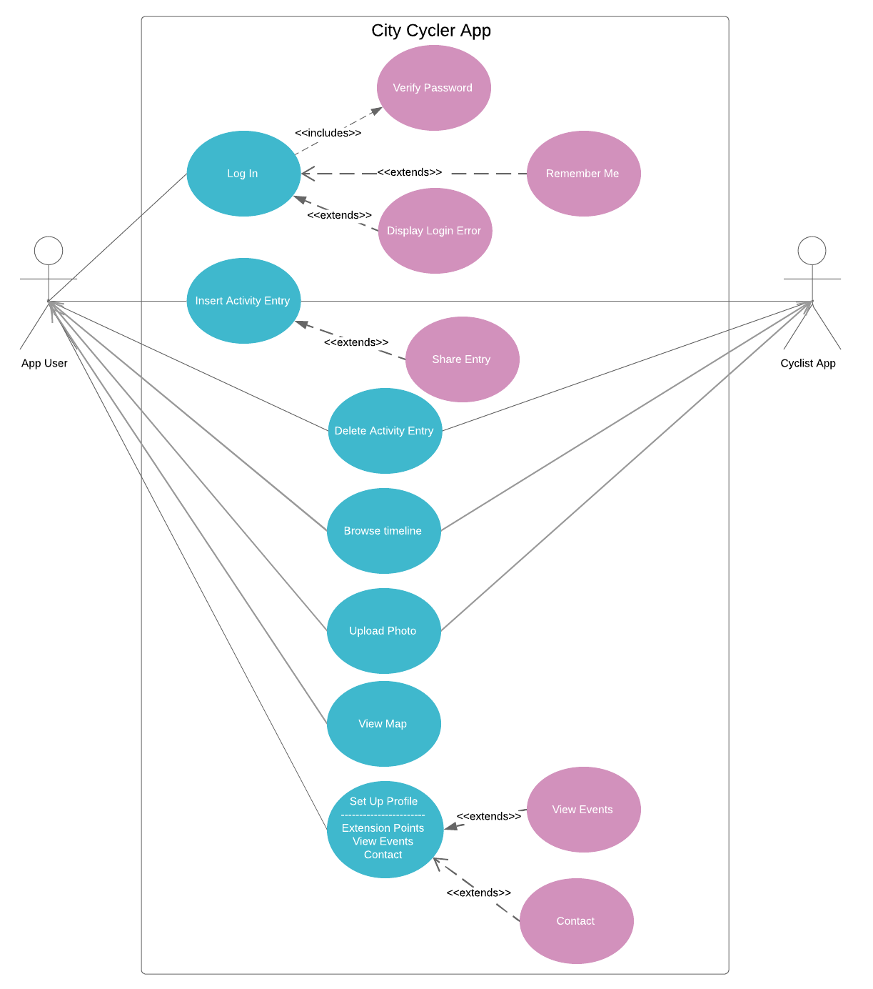

**CREDITS**

|  |  |
| --- | --- |
| Introduction  Purpose  Scope  Definitions Acronyms Abbreviations  References  General Constraints | Firdevs Mersin |
| Assumptions and Dependencies  Requirements | Dilara Bayar |
| Use Case Diagram | Serdar Sayın |